The EStrella Piano Duo burst onto the musical scene in 2011 with a series of concerts celebrating the great Russian masterpieces for piano duet. Elena Doubovitskaya and Svetlana Belsky share both their Russian heritage and training, and their enthusiasm for playing together. Elena and Svetlana are accomplished soloists and chamber musicians. Between the two, they have been heard throughout Europe, Asia and the United States, with numerous orchestras, and on the radio. Their concert credits include Carnegie (Weill) Hall, Kiev Philharmonic Hall, St. Petersburg Rimsky-Korsakoff Museum, Baptist University of Hong Kong, and Tanglewood Music Festival. Critics praise them for “marvelous and extraordinary playing” and “confidence and élan”. Elena and Svetlana are also accomplished teachers, who love sharing their love for music with new generations of pianists.
Their first performance together evoked raves of “technical brilliance” and “infectious joy in music making”. The second drew a standing-room-only crowd. Since then they have presented concerts and masterclasses throughout the United States. The 2013-14 season took them to countless university series, several concerts on the East Coast and all over the Midwest. A highlight of the 2014 season was an exciting collaboration with the Clinard Dance Company for live performances of Stravinsky’s Rite of Spring. The group will be taking the production to China and Hong Kong in 2016.
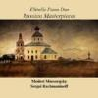
Discography (available on CD or DVD): Russian Masterpieces: Rachmaninoff and Mussorgsky
M. Mussorgsky, The Hut of Baba Yaga and The Great Gate of Kiev from Pictures at an Exhibition, (arranged by Catherine McMichael for Two Pianos), S. Rachmaninoff, Vocalise (arranged by Greg Anderson for piano four hands), and Suite No. 2, Op. 17 for Two Pianos

On YouTube: https://www.youtube.com/user/EStrellaPianoDuo/videos
Website: http://www.elena-doubovitskaya.com/EstrellaDuo.html

A native of Russia, Elena Doubovitskaya performed her debut recital in Carnegie Hall’s Weill Recital Hall as part of Artists International Presentations, followed by numerous engagements in United States, Germany, Austria, Czech Republic and Russia. Dr. Doubovitskaya’s accomplishments include awards from Artists International Presentations, the Seattle International Piano Competition and the Ibla Grand Prize Competition. She has performed at the Tanglewood Music Festival, Prague International Piano Master Classes and East-West Music Festival in Germany, among others, and has participated in master classes with Emanuel Ax, James Levine, Leif Ove Andsnes, Garrick Ohlsson, and Menahem Pressler. Dr. Doubovitskaya received her undergraduate degree from the Ural State “Mussorgsky” Conservatory in Ekaterinburg, Russia, followed by a Master’s Degree from the Manhattan School of Music under Solomon Mikowsky and a Doctorate Degree in Piano Performance from Northwestern University under Ursula Oppens. Currently Dr. Doubovitskaya is a member of the piano and chamber music faculty at the Merit School of Music in Chicago, and serves as the Chairman of its Piano Department.

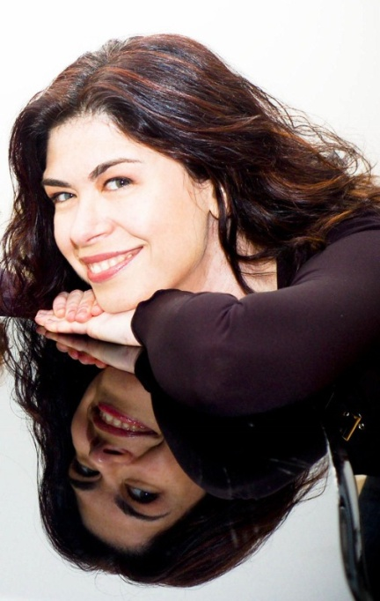
Critically acclaimed as "a passionate pianist and scholar", Svetlana Belsky is an in-demand recitalist and chamber pianist, noted for her remarkable rapport with audiences and stylistic versatility. She has appeared in the Ukraine, Russia, Poland, China, Taiwan and Hong Kong, and throughout the United States. Her performance credits include Carnegie Recital Hall, Kiev Philharmonic Hall, Dame Myra Hess Series, Music in the Loft, countless university concert series, live recitals on Chicago's WFMT and New York's WQXR, and guest appearances with the University of Chicago Symphony, Southern Illinois Symphony, Chicago Chamber Orchestra and the Tutti Orchestra. Dr. Belsky has received awards both for her performances in international piano competitions, and for her advocacy of new American music. Her recordings have been heard on radio stations worldwide. Her annotated translation of Busoni as Pianist has been nominated for an American Musicological Society award. Following emigration from the Soviet Union, Dr. Belsky studied with Emilio Del Rosario in Chicago. She earned her Bachelor of Music summa cum laude and Master's degrees from the Peabody Conservatory of Music, studying with Ann Schein. Later, she earned her Doctorate in Performance at the Manhattan School of Music, working with Nina Svetlanova. As the Coordinator of Piano Studies at the University of Chicago, Dr. Belsky teaches students from four continents, among many other academic responsibilities.

…“breathtaking”
“We concluded our very successful 2013/14 classical concert season on Sunday, May 18, with the magnificent EStrella Piano Duo – comprised of two Soviet émigrés, Elena Doubovitskaya and Svetlana Belsky, who currently live in Chicago. Their breathtaking performance in our hall, including the very personal introductions of each piece by Svetlana, certainly kept me in thrall.”
Hardy von Auenmueller, Music Director, German Society of Philadelphia

…“charged”
“Duo-pianists Elena Doubovitskaya and Svetlana Belsky offered a muscular and charged Rite of Spring. The event was a two-piece, multi-disciplinary performance with dance at the heart… always engaging, sometimes inventive, and in some perfectly timed moments, stunningly beautiful.”
-M. L. Rantala, Classical Music Critic, the Hyde Park Herald

…“infectious joy”
“The EStrella Piano Duo's performance of Rachmaninov's 2nd Suite was a pleasure to hear – it combined technical brilliance with uncanny coordination, and an infectious joy in music-making.”
-Timothy Riordan, Artistic Director, Merit School of Music, Chicago.

…obvious skill, talent and musicianship”
“The response to your performance was positive in every respect: your choice of music, its execution and interpretation and the obvious skill, talent and musicianship you both possess. I hope we can arrange for a repeat visit in the future.”
-Gloria Cook, Director, Meadow Lakes Community Concerts, NJ

…“stunning virtuosity”
“The EStrella Piano Duo possesses a stunning virtuosity that makes their Russian repertory leap from the page. I feel the audience truly connected with their performance through their captivating musicianship.”
-Steve Gianni, Artistic Director, Two-Piano Festival, Northbrook Public Library

…“stellar performance”
“Thank you to both of you for providing such a stellar performance and being so easy to work with!”
-Stacy Michel, Program Coordinator, Gail Borden Public Library

…“fantastic”
“Your program last fall was just terrific. I thought you both were fantastic and I really enjoyed the spirit with which you performed. You seldom see people who work so well together.”
-Mary-Christine Stingley, Musicians Club of Women concert director

Programs Available for 2015-2017

- Masterpieces by Russian and Slavic Composers (one piano-four hands). Transcriptions of beloved works such as Scheherazade and Polovetsian Dances, along with other works by Rachmaninoff, Tchaikovsky, Gavrilin and Stravinsky

- Russian Favorites (two pianos). The magnificent Suite No. 2 by Rachmaninoff, settings of Rachmaninoff’s Songs, Pictures at an Exhibition and more

- A Celebration of the Waltz (for one piano/ four hands and two pianos). Ravel’s La Valse opens with a vision of tragedy, and an uproarious and acrobatic setting of The Blue Danube Waltzes by Greg Anderson lightens the mood

- Mozart and Friends (two pianos). Starting with Mozart’s great Sonata for Two pianos, this program moves on to variations, transcriptions and paraphrases by other composers ranging from the serious to the Ragtime a la Turca by Greg Anderson

- The Rite of Spring (one piano). Stravinsky’s piano duet setting is often performed on two pianos, but the EStrella Duo showcases the far more difficult original one piano version

- Music by French and German composers (for one piano). Works by Debussy, Ravel, Bach, Mozart, Beethoven and Mendelssohn

These progams may of course be combined in any way that best suits the venue and the audience.

